Subject Name: Wireless Communication

Subject Code: CSP311M

Name: Charvik Patel

Roll no: 1401079

Practical Number: 1

Aim: Path loss in Different Environment (ideal, urban, indoor) and their Receiver Antenna Power as increase in distance.

Brief Theory:

1. Free Space:

$p_{r}=p_{t}*G_{t}*G_{r}*(\frac{λ}{4*π*d})$

$p_{r}:Reciever Antenna Power$

$$p_{t}:Transmited Antenna Power$$

$$G_{t}:Transmiter Antenna Gain$$

$$G_{r}:Reciever Antenna Gain$$

$λ=\left(\frac{c}{f}\right) :Wavelenght (∴c:Speed of light , f:frequency$)

$$d:distance$$

1. Two Ray:

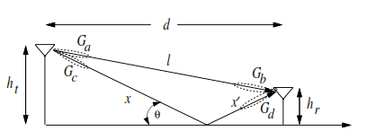

$p_{r}=p_{t}*{\left(\frac{λ}{4*π}\right)}^{2}*\left|\left(\frac{\sqrt{G_{l}}}{l}+\frac{R*\sqrt{G_{r}}*{ e}^{\left(-1j*Δϕ\right)}{}}{x+x^{'}}\right)\right|$

$p_{r}:Receiver Antenna Power$

$$p_{t}:Transmited Antenna Power$$

$λ=\left(\frac{c}{f}\right) :Wavelenght (∴c:Speed of light , f:frequency$)

$$d:distance$$

$$G_{l}=\sqrt{G_{a}*G_{b}} :Antenna Gain of Direct sight path$$

$$G_{r}=\sqrt{G_{c}*G_{d}}:Antenna Gain of Reflected sight path$$

$$Δϕ:Phase Diffrence$$

$$x+x^{'}:Reflected Ray path (lenght)$$

$$l:Direct Line of sight path\left(Ray\right)(lenght)$$

$$R:Ground Reflection Coefficient$$

1. Ten Ray:

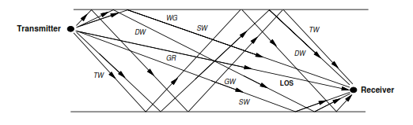

$p_{r}=p_{t}*{\left(\frac{λ}{4*π}\right)}^{2}*\left|\left(\frac{\sqrt{G_{l}}}{l}+\frac{R_{i}*\sqrt{G_{r_{i}}}*{ e}^{\left(-1j*Δϕ_{i}\right)}{}}{x_{i}}\right)\right|$

$p_{r}:Receiver Antenna Power$

$$p_{t}:Transmited Antenna Power$$

$λ=\left(\frac{c}{f}\right) :Wavelenght (∴c:Speed of light , f:frequency$)

$$d:distance$$

$$G_{l}=\sqrt{G_{a}*G_{b}} :Antenna Gain of Direct sight path$$

$$G_{r_{i}}=\sqrt{G_{c_{i}}*G_{d_{i}}}:Antenna Gain of Reflected sight path$$

$$Δϕ_{i}:Phase Diffrence$$

$$x_{i}:Reflected Ray path (lenght)$$

$$l:Direct Line of sight path\left(Ray\right)(lenght)$$

$$R_{i}:Ground Reflection Coefficients$$

Matlab Code:

1. Free Space:

Code:

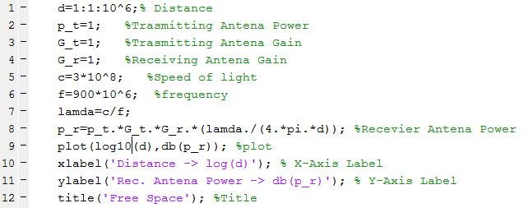

Simulation Results:



1. Two Ray:

Code:

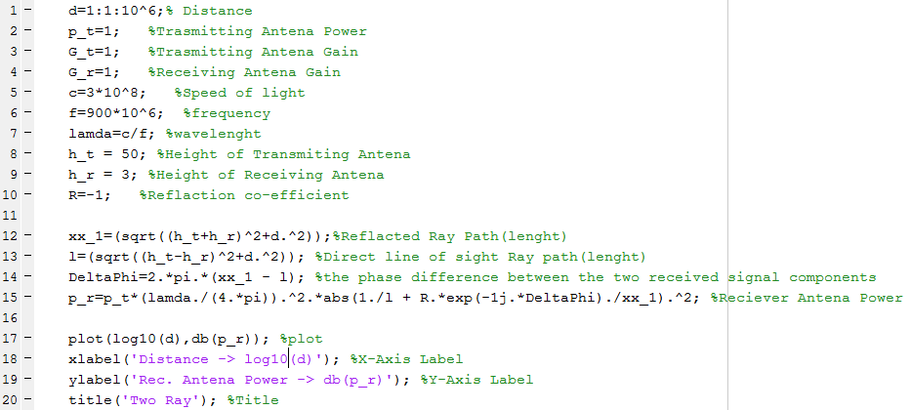

Simulation Results:



1. Ten Ray:

Code: 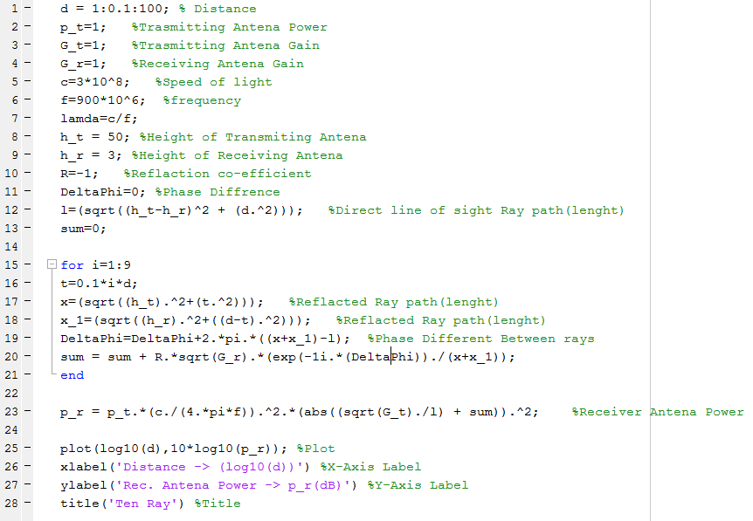

Simulation Results:



Result interpretation:

1. As per Equation of the Free Space, Two Ray, Ten Ray Power of Receiving Antenna is Inversely Proportional to the Square of distance between Transmitting Antenna and Receiving Antenna and dependent on Reflection Co-efficient factor
2. As number of Rays increases the Signal Distortion Increases as we can observe from Two Ray and Ten Ray